**MANUAL TESTING**

**1.Write a Bug Report for a bug in whatsapp mobile app**

**Bug ID:1**

**Summary:user unable to send the video files in group chats**

**Description:I have checked the issues as a user perspective and unable to send the videos files in Group Chats but its working in Private Chats**

**Step to Reproduce:**

**1.Open whatsapp Mobile application**

**2.Open the Group Chats**

**3.Then click on the Attach Symbol which visible near the text box**

**4.Then Click on the Gallery**

**5.Then click any video and click Send Button**

**Environment:Android**

**Severity:High**

**Priority:Medium**

**Expected Results:User can able to send the videos in group Chats**

**Actual Results:User Unable to send the videos in group chats**

**Visual Proof:Screenshot attached for Reference**

**Reported By:Tester**

**Reported On:Date**

**Status:open**

**Assigned to:Developer**

**2.Write a bug report for a bug in the login page that the submit button is not working**

**Let assume a food app login page submit button is not working**

**Bug ID:2**

**Summary:Submit button is not working in login Page**

**Description:I have checked the issues as a user perspective and i tried to login a food app but submit button is not working**

**Step to Reproduce:**

**1.Open Food application**

**2.Then Click on Login**

**3.Enter Your Valid User ID**

**4.Then Enter your Correct Password**

**5.Then click on Submit Button**

**Environment:Android**

**Severity:High**

**Priority:Medium**

**Expected Results:Submit Button have to work and User can access**

**Actual Results:User Submit Button is not working**

**Visual Proof:Screenshot attached for Reference**

**Reported By:Tester 1**

**Reported On:Date**

**Status:Open**

**Assigned to:Developer 1**

**3.Write a Bug Report for Profile Picture not updated in Whatsapp**

**Bug ID:0003**

**Summary:Profile Picture is not Updated I whatsapp application**

**Description:** **When user uploads a photo, placeholder image doesn't get replaced until the user refreshes. This should happen right away as soon as the upload is completed.**

**Step to Reproduce:**

**1.Open Food application**

**2.Then Click on Login**

**3.Enter Your Valid User ID**

**4.Then Enter your Correct Password**

**5.Then click on Submit Button**

**Environment:Android**

**Severity:High**

**Priority:Medium**

**Expected Results:Submit Button have to work and User can access**

**Actual Results:User Submit Button is not working**

**Visual Proof:Screenshot attached for Reference**

**Reported By:Tester 1**

**Reported On:Date**

**Status:open**

**Assigned to:Developer 1**

**4.Write a few Testcases for booking tickets in Redbus**

* **Go to redbus.in**
* **Select source and destination,Date of journey,return journey date(not compulsory).**
* **Then click on Search button**
* **Then you will get a list of available buses on journey date,time,available seats and their fares.**
* **Select the bus you want and select the seats.Then**
* **Then select boarding pont and continue.Then select return journey bus and tickets,if applicable**
* **On the checkout page,fill your details and select payment option(Credit card,Debit card,Net banking )and Finish**

**5.Write any 5 Negative test cases**

* **Try to enter an invalid email id**
* **Attempt to submit after expired authentication**
* **Attempt to access a page without permission**
* **Try to entry invalid phone number in a phone number field**
* **Upload image with size out of specified boundary**

**6.Write a few test cases for IRCTC Web Application**

* **Open the IRCTC web application.**
* **Then register as an individual.**
* **Login by entering your User name and Password.**
* **Provide Your Desired from and To Station,Date of journey and Class of travel.**
* **To find train list,click on Search Option.**
* **The next page displays the lists of trains available for the selected route.**
* **To select the train from the train list,click on the type of class available in the selected train.**
* **And fare of the ticket will appear on the screen.**
* **To book the ticket,Click on Book Now button.**
* **Then Passenger Reservation Page wil appear,check whether the train name,station names,class and journey date displayed on the page are same as desired by you.**
* **Then enter the passengers details.**
* **After providing correct details,click on Continue button.**
* **The ticket details,total fare and availability of berths at the particular time will appear on the screen.**
* **After checking all details,Click on Continue Button for payment process.**
* **Select the desired payment option from the displayed payment Gateway menus.**
* **Click on Pay and Book button for redirection to selected bank website.**
* **After successful payment and booking of accommodations,Ticket Confirmation page will appear.**

**7. Write a few test cases for Spicejet Web Application**

* **Verify that there is a portal to add new flights in the system.**
* **Verify that on filling flight details like flight name, code, from and to destinations, capacity, timings, and frequency etc, new filghts get successfully added in the system.**
* **Verify that users can search for flights by name, from-to airports or flight code for checking their status and timings.**
* **Verify that search results have flight details, timings and availability.**
* **Verify that clicking the search results open complete details for flight.**
* **Verify that the user should see realtime flight status of availability of seats.**
* **Verify that the user is presented with a graphical view of the airline’s sitting arrangement along with seat number and availability status.**
* **Verify that the pricing of different types of seats is displayed to the users.**
* **Verify that users can successfully select single or more than one seat.**
* **Verify that the user can not select or is not permitted to select seats that are already booked or not allowed for booking.**
* **Verify that after selecting seats, entering passenger details and making payment the selected seats get booked.**
* **Verify that on successful booking the ticket should be visible and downloadable.**
* **Verify that after successful booking the seat’s status is updated to booked.**
* **Verify that the user also receives confirmation mail along with tickets on the emailIds provided while filling the details.**
* **Verify the maximum limit of seats that a user can book, selecting more seats than permitted results in error message.**
* **Verify that all the different types of payment methods work fine.**
* **Verify that user is presented with additional options like- luggage, extra legroom, foods/beverages, etc and selecting the same results in additional cost with the booking amount.**
* **Verify that the user can also cancel the tickets booked by entering the mandatory details and the amount after deducting the cancellation fee gets refunded back to user.**
* **Verify that after cancellation the seat’s status is updated to available.**

**8.Create 10 test cases for amazon mobile view**

* **First check that application downloaded properly for your mobile**
* **Then open the amazon mobile app**
* **Then log in process will appear on the screen**
* **Now enter the valid user name**
* **Then enter the valid password**
* **Then click on Sign in button**
* **Check whether the product is adding to the cart**
* **Check whether you can track your order after placement**
* **If your not having an accounts means.After open the application click on create new account**
* **Then fill the valid details then save**

**SELENIUM**

**9.** **Write code for taking Screenshot**

**package newjavase;**

**import java.io.File;**

**import java.io.IOException;**

**import org.apache.commons.io.FileUtils;**

**import org.openqa.selenium.OutputType;**

**import org.openqa.selenium.TakesScreenshot;**

**import org.openqa.selenium.WebDriver;**

**import org.openqa.selenium.chrome.ChromeDriver;**

**public class screenshot2 {**

**public static void main(String[] args) throws IOException {**

**// TODO Auto-generated method stub**

**WebDriver driver = new ChromeDriver() ;**

**System.setProperty("webdriver.chrome.driver", "C:\\Users\\nandh\\Downloads\\chromedriver_win32 \\chromedriver.exe");**

**driver.manage().window().maximize();**

**driver.get("https://www.amazon.com/");**

**File screenshoting = ((TakesScreenshot)driver).getScreenshotAs(OutputType.FILE);**

**FileUtils.copyFile(screenshoting, new File("C:\\Users\\nandh\\OneDrive\\Desktop\\amazonscreenshot.png"));**

**}**

**}**

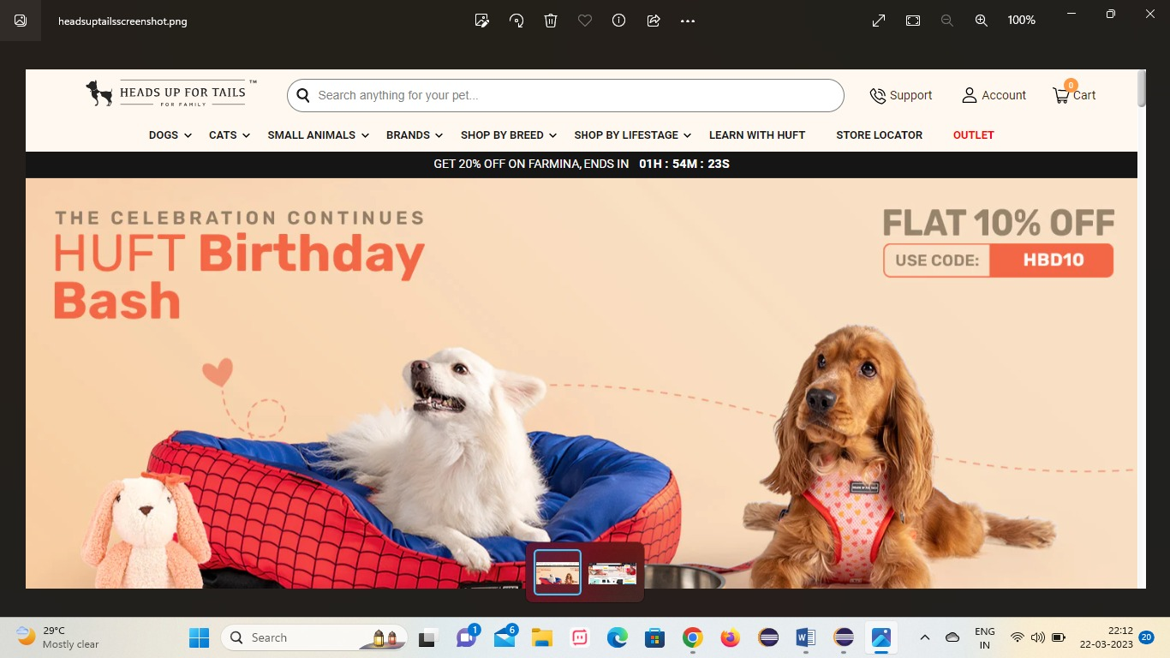

**10.Automate Menu and Sub Menu and click on a link in Sub Menu and navigate to the page and click on an element**

**package newjavase;**

**import org.openqa.selenium.By;**

**import org.openqa.selenium.WebDriver;**

**import org.openqa.selenium.WebElement;**

**import org.openqa.selenium.chrome.ChromeDriver;**

**import org.openqa.selenium.edge.EdgeDriver;**

**import org.openqa.selenium.support.ui.Select;**

**public class dropdown {**

**public static void main(String[] args) throws InterruptedException {**

**// TODO Auto-generated method stub**

**WebDriver driver = new EdgeDriver();**

**System.setProperty("webdriver.chrome.driver", "C:\\Users\\nandh\\Downloads\\chromedriver_win32 \\chromedriver.exe");**

**driver.manage().window().maximize();**

**driver.get("https://rahulshettyacademy.com/dropdownsPractise/");**

**//create a webelement and assign the locator of the dropdown to it:**

**WebElement dropdownelement = driver.findElement(By.id("ctl00_mainContent_DropDownListCurrency"));**

**//Select tag to use select attributes and create the obiect of select class:**

**Select dropdown = new Select(dropdownelement);**

**System.out.println("The currencies from dropdown are:");**

**//method 1 select by index**

**dropdown.selectByIndex(1);**

**System.out.println(dropdown.getFirstSelectedOption().getText());**

**Thread.sleep(1000);**

**//method 2 select by visible text**

**dropdown.selectByVisibleText("USD");**

**System.out.println(dropdown.getFirstSelectedOption().getText());**

**Thread.sleep(1000);**

**//method 3 select by value**

**dropdown.selectByValue("AED");**

**System.out.println(dropdown.getFirstSelectedOption().getText());**

**driver.findElement(By.id("divpaxinfo"));**

**driver.findElement(By.id("hrefIncAdt"));**

**for(int i=0;i<6;i++) {**

**driver.findElement(By.id("hrefIncAdt"));**

**}**

**OUTPUT:**

**The currencies from dropdown are:**

**INR**

**USD**

**AED**